**Step 1: Drawing Basic Shapes With Python Turtle**

1. Create an new Repl by selecting the **“Python with Turtle”** language / environment.

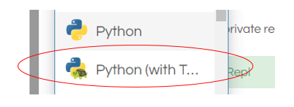

1. Begin all of your turtle programs with the following code to create a “pen”:

import turtle

myPen = turtle.Turtle()

1. Review the following chart for a list of Turtle commands.

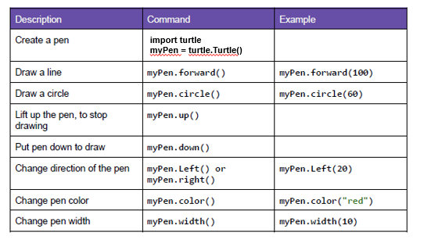

1. Use the following program to draw a red square.

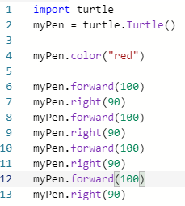

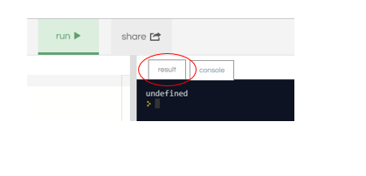

1. Switch to the “Result” window to see the square.
2. Create a program to draw any one of the shapes “b”, ”d”, or “e” shown in the figures below.   
   Provide a listing of your program code.

D

1. import turtle
2. myPen = turtle.Turtle()
3. myPen.right(45)
4. myPen.forward(70)
5. myPen.backward(140)
6. myPen.forward(70)
7. myPen.left(90)
8. myPen.forward(70)
9. myPen.backward(140)
10. Create a program to draw any one of the shapes “c”, or “f” shown in the figures below.   
    Provide a listing of your program code.

C

1. import turtle
2. myPen = turtle.Turtle()
3. myPen.circle(50)
4. myPen.forward(50)
5. myPen.left(90)
6. myPen.forward(100)
7. myPen.left(90)
8. myPen.forward(100)
9. myPen.left(90)
10. myPen.forward(100)
11. myPen.left(90)
12. myPen.forward(50)

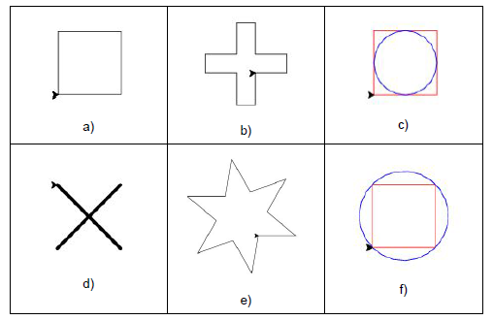

**Step 2: Christmas / Winter Theme Card**

1. Use your creativity to create a card design using Turtle.
   1. The design must have multiple figures.
   2. The design must have at least two different patterns.
   3. You may repeat patterns.
   4. Provide a listing of your program code.
   5. Provide an image of your program result.

import turtle

myPen = turtle.Turtle()

myPen.forward(100)

myPen.left(60)

myPen.forward(100)

myPen.left(120)

myPen.left(36)

myPen.forward(100)

myPen.left(60)

myPen.forward(100)

myPen.left(120)

myPen.left(36)

myPen.forward(100)

myPen.left(60)

myPen.forward(100)

myPen.left(120)

myPen.left(36)

myPen.forward(100)

myPen.left(60)

myPen.forward(100)

myPen.left(120)

myPen.left(36)

myPen.forward(100)

myPen.left(60)

myPen.forward(100)

myPen.left(120)

myPen.left(36)

